

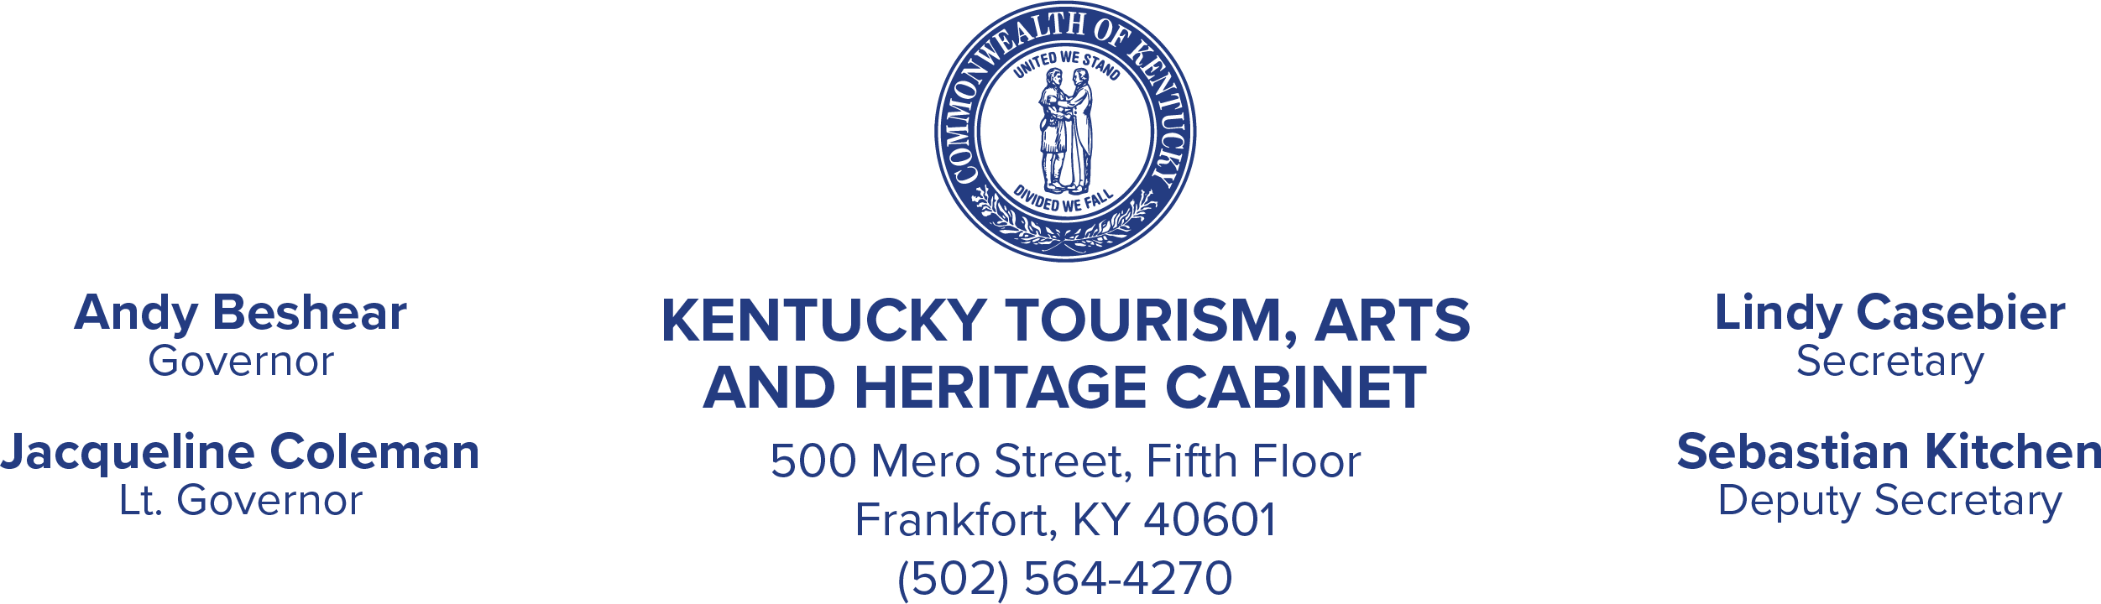Memorandum

To: Senator Chris McDaniel, Co-Chair Representative Jason Petrie, Co-Chair Appropriations and Revenue Committee

Senator Matt Nunn, Co-Chair Representative Chris Fugate, Co-Chair

Budget Review Subcommittee on Economic Development, Tourism and Environmental Protection

From: Russ Meyer, Commissioner Kentucky Department of Parks Tourism, Arts and Heritage Cabinet

Date: June 30, 2025 Subject: House Bill 6 Report

Please see the attached reporting regarding House Bill 6.

If you have questions concerning this request, please contact Mona Juett at (502) 892-3320 or [mona.juett@ky.gov.](mailto:mona.juett@ky.gov)